A000-Xian-Eur-Chersonesus-Coin-City Issue- Chersonas, Nike-47-55 CE

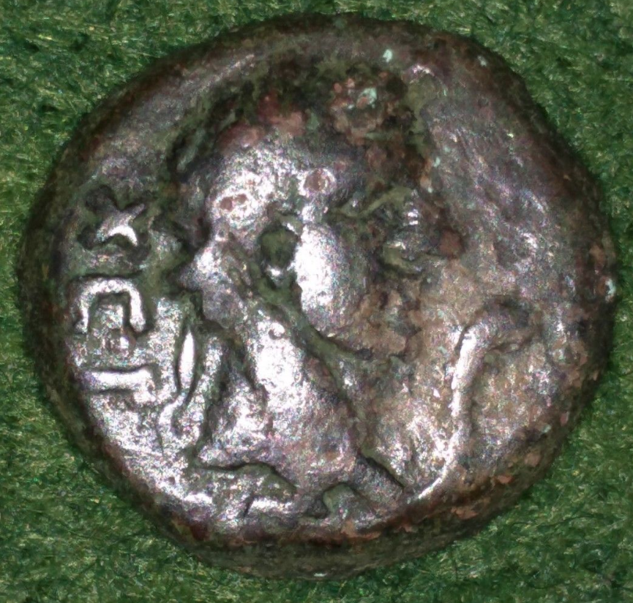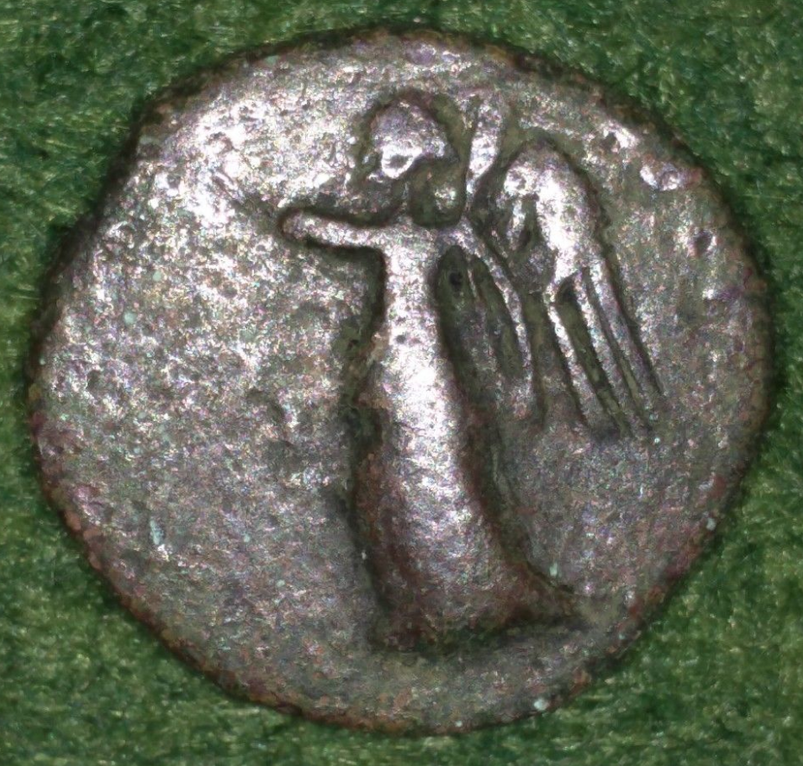

Very rare city issue of the Greek city of Chersonesus/Chersonesos.   
  
Circa AD 47/48-54/55   
Obverse: Head of Chersonas right, wearing laurel wreath; XEP to left, serpent to right   
Reverse: Nike advancing left, holding wreath in extended right hand and cradling palm frond in left arm; monogram to left.   
Weight: 5.17g   
Size: 16mm   
References: Anokhin 849 var.   
From a Canadian collection. **US $156.25**  
  
This coin is similar to Triton XVI, lot 149.   
  
The primary reference for coins of Chersonesus is Anokhin's book, The Coinage of Chersonesus, which is in Russian and has been translated into English by H. Bartlett Wells (BAR International Series 69, 1980). Five types are listed in Sear's Greek Coins and their Values, volume I, 1664-1668 on pages 165-166.  SNG XI Stancomb and SNG IX British Museum, The Black Sea, also cover this region, but not nearly as thoroughly.    
  
About the City:   
  
Tauric Chersonesos, opposite modern Sevastopol', located on the western coast of the peninsula of Crimea, was founded circa 422 BCE by colonists from Herakleia Pontika and Delion in Boiotia. The city quickly rose in stature through its wine production, but also through its location, which was ideal for trade compared to the other cities in the Cimmerian Bosporos. In turn, as the city grew, Chersonesos established a colony at Karkinitis on the northwest coast of the Crimea.   
  
In the second century BCE, the city became a target of Skythian raids, and it was forced to appeal to Mithridates VI of Pontus for protection. The Pontic king saved the city from the Skythians, but now incorporated Chersonesos into his own dominion. With the passing of Mithridates, the city became a part of the Kingdom of Bosporos, but finally regained its independence by declaration of the Romans in 36 BCE.

# The Coinage of the Kingdom of Bosporus AD 69-238

## [N.A. Frolova](https://www.abebooks.com/servlet/SearchResults?an=N.A.+Frolova&cm_sp=det-_-bdp-_-author)

Published by B.A.R. (British Archaeological Research), Oxford, England, 1979

**The coinage of the kingdom of Bosporus, A.D. 242-341/342**

#### **1983**[**Oxford, England**](https://openlibrary.org/search/subjects?q=Oxford,%20England) **by**[**B.A.R.**](https://openlibrary.org/publishers/B.A.R.)

### [The coinage of the Bosporan Kingdom](https://openlibrary.org/works/OL2104699W)

by [N. A. Frolova](https://openlibrary.org/authors/OL260314A)1 edition - first published in 2002

### [Essays on the Northern Black Sea region numismatics](https://openlibrary.org/works/OL2104703W)

### by [N. A. Frolova](https://openlibrary.org/authors/OL260314A)1 edition - first published in 1995’’**Essays on the Northern Black Sea region numismatics** Nina Frolova ; [translation: H. Bartlett Wells]. Edition Notes

Originally published in Russian under title: Ocherki po numizmashike Severnoso Lrichernomor'i︠a︡.

#### Published **1995** by [Polis Press](https://openlibrary.org/publishers/Polis_Press) in [Odessa, Ukraine](https://openlibrary.org/search/subjects?q=Odessa,%20Ukraine) .